Mathematical Formulas

A report describing the Mathematical Formulas used for the Network Appliance Service Utilisation Framework

Version: 0.1

By

Paul Fergus

Supervised by

Dr. Martin Hanneghan and Prof. Madjid Merabti

Networked Appliances Lab
School of Computing and Mathematical Sciences
Liverpool John Moores University

Table of Contents
Table of Contents ii
Table of Figures v
1 Mathematical Formula: Time-to-Live (TTL) of Service Requests 1
1.1 Description 1
1.2 Assumptions 1
1.3 Formula Decomposition 1
1.4 Example 1
1.5 Mathematical Formula: Bandwidth Requirements 2
1.6 Description 2
1.7 Assumptions 2
1.8 Formula Decomposition 2
1.9 Example 2
2 Mathematical Formula: Probability of Finding a Term in the Global Ontology 3
2.1 Description 3
2.2 Assumptions 3
2.3 Formula Decomposition 3
2.4 Example 3
3 Mathematical Formula: Probability of Finding Relationships between Terms in the Global Ontology 4
3.1 Description 4
3.2 Assumptions 4
3.3 Formula Decomposition 4
3.4 Example 4
4 Mathematical Formula: Probability of Finding a Service in the P2P Network 5
4.1 Description 5
4.2 Assumptions 5
4.3 Formula Decomposition 5
4.4 Example 5
5 Mathematical Formula: Service Definition 6
5.1 Description 6
5.2 Assumptions 6
5.3 Formula Decomposition 6
5.4 Example 6
6 Mathematical Formula: Service Profile 7
6.1 Description 7
6.2 Assumptions 7
6.3 Formula Decomposition 7
6.4 Example 7
7 Mathematical Formula: Service Process Model 8
7.1 Description 8
7.2 Assumptions 8
7.3 Formula Decomposition 8
7.4 Example 8
8 Mathematical Formula: Service Grounding Model 9
8.1 Description 9
8.2 Assumptions 9
8.3 Formula Decomposition 9
8.4 Example 9
9 Mathematical Formula: Atomic Process 10
9.1 Description 10
9.2 Assumptions 10
9.3 Formula Decomposition 10
9.4 Example 10
10 Mathematical Formula: Service Interface 11
10.1 Description 11
10.2 Assumptions 11
10.3 Formula Decomposition 11
10.4 Example 11
11 Mathematical Formula: Signature Definition 12
11.1 Description 12
11.2 Assumptions 12
11.3 Formula Decomposition 12
11.4 Example 12
12 Mathematical Formula: Signature Composability 13
12.1 Description 13
12.2 Assumptions 13
12.3 Formula Decomposition 13
12.4 Example 13
13 Mathematical Formula: Sequential Reliability of Service Composition 14
13.1 Description 14
13.2 Assumptions 14
13.3 Formula Decomposition 14
13.4 Example 14
14 Mathematical Formula: Parallel Reliability of Service Composition 16
14.1 Description 16
14.2 Assumptions 16
14.3 Formula Decomposition 16
14.4 Example 17
15 Mathematical Formula: Serial-Parallel Reliability of Service Composition 18
15.1 Description xxx 18
15.2 Assumptions 18
15.3 Formula Decomposition 18
16 Mathematical Formula: Parallel-Serial Reliability of Service Composition 20
16.1 Description 20
16.2 Assumptions 20
16.3 Formula Decomposition 20
17 References 21

Table of Figures
Figure 1 TTL of Service Requests 1
Figure 2 Bandwidth Requirements 2
Figure 3 Probability of finding a Term in the Global Ontology 3
Figure 4 Probability of finding Relationships between Terms in the Global Ontology 4
Figure 5 Probability of Finding a Service in the P2P Network 5
Figure 6 Service Definition 6
Figure 7 Service Profile 7
Figure 8 Service Process Model 8
Figure 9 Service Grounding Model 9
Figure 10 Atomic Process 10
Figure 11 Service Interface 11
Figure 12 Signature Definition 12
Figure 13 Signature Composability 13
Figure 14 Serial Reliability of Service Composition 14
Figure 15 Parallel Reliability of Service Composition 16
Figure 16 Serial-Parallel Reliability of Service Composition 18
Figure 17 Parallel-Serial Reliability of Service Composition 20

Mathematical Formula: Time-to-Live (TTL) of Service Requests

Description
This Mathematical Model defines SOMETHING within this framework. The Mathematical Model is illustrated in Figure 1.

Figure 1 TTL of Service Requests

Assumptions
Describe all the assumptions used within this Mathematical Model

Formula Decomposition
Describe the Mathematical Model

Example

Mathematical Formula: Bandwidth Requirements

Description
This Mathematical Model defines SOMETHING within this framework. The Mathematical Model is illustrated in Figure 1.

Figure 2 Bandwidth Requirements

Assumptions
Describe all the assumptions used within this Mathematical Model

Formula Decomposition
Describe the Mathematical Model

Example

Mathematical Formula: Probability of Finding a Term in the Global Ontology

Description
This Mathematical Formula defines the probability of finding a term in a global ontology. The Mathematical Formula is illustrated in Figure 1.

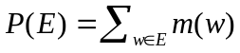
(1)

Figure 3 Probability of finding a Term in the Global Ontology

Assumptions
Describe all the assumptions used within this Mathematical Model

Formula Decomposition

Example
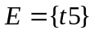
X is the outcome of this experiment, i.e. one of the possible values in 
The distribution function for X is a real-valued function m whose domain is and which satisfies:
1. 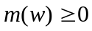 for all Error! Objects cannot be created from editing field codes., and
2. 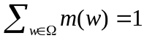
P(E) = m(t5)
= 

Mathematical Formula: Probability of Finding Relationships between Terms in the Global Ontology

Description
This Mathematical Model defines the probability of finding a relationship between two terms in the global ontology. The Mathematical Model is illustrated in Figure 1.

(1)

Figure 4 Probability of finding Relationships between Terms in the Global Ontology

Assumptions
Describe all the assumptions used within this Mathematical Model

Formula Decomposition

Example
X is the outcome of this experiment, i.e. one of the possible values in
The distribution function for X is a real-valued function m whose domain is and which satisfies:
1. for all Error! Objects cannot be created from editing field codes., and
2.
P(E) = m(t5) + m(t6)
= +
= 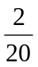

Mathematical Formula: Probability of Finding a Service in the P2P Network

Description
This Mathematical Formula defines the Standard Deviation to determine how close a service request matches a service description. The Mathematical Formula is illustrated in Figure 1.
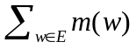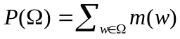

Figure 5 Probability of Finding a Service in the P2P Network

Assumptions
Need to do

Formula Decomposition
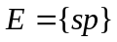
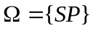

Example

Mathematical Formula: Service Definition

Description
This Mathematical Model defines the formula used to describe a service description within this framework. The Mathematical Model is illustrated in Figure 1.
(1)
Figure 6 Service Definition

Assumptions
Describe all the assumptions used within this Mathematical Model

Formula Decomposition
Si = (SP, SPM, SG, SI)
SP = Service Profile (1.1)
SPM = Service Process Model (1.1)
SG = Service Grounding (1.1)
SI = Service Interface (1.1)

Example

Mathematical Formula: Service Profile

Description
This Mathematical Model defines the formula used to describe a service profile within this framework. The Mathematical Model is illustrated in Figure 1.
(1)
Figure 7 Service Profile

Assumptions
Describe all the assumptions used within this Mathematical Model

Formula Decomposition
I_{x} = Input (1.n)
O_{x} = Output (1.n)
P_{x} = Precondition (1.n)
E_{x} = Effect (1.n)
D_{x} = Domain {domain(i) | i exists I}, {domain(o) | o exists O}
R_{x} = Range {range(i) | i exists I}, {range(o) | o exists O}

Example

Mathematical Formula: Service Process Model

Description
This Mathematical Model defines the formula used to describe a service process model within this framework. The Mathematical Model is illustrated in Figure 1.
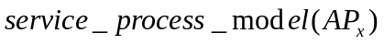
(1)
Figure 8 Service Process Model

Assumptions
Describe all the assumptions used within this Mathematical Model

Formula Decomposition
AP_{x} = Atomic Process (1.n)

Example

Mathematical Formula: Service Grounding Model

Description
This Mathematical Model defines the formula used to describe a service grounding within this framework. The Mathematical Model is illustrated in Figure 1.
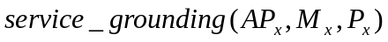
(1)
Figure 9 Service Grounding Model

Assumptions
Describe all the assumptions used within this Mathematical Model

Formula Decomposition
AP_{x} = Atomic Process (1.n)
M_{x} = Message (1.n)
P_{x} = PortType (1.n)

Example

Mathematical Formula: Atomic Process

Description
This Mathematical Model defines the formula used to describe an atomic process within this framework. The Mathematical Model is illustrated in Figure 1.
(1)
Figure 10 Atomic Process

Assumptions
Describe all the assumptions used within this Mathematical Model

Formula Decomposition
I_{x} = Input (1.n)
O_{x} = Output (0.1)
P_{x} = Precondition (1.n)
E_{x} = Effect (1.n)
D_{x} = Domain {domain(i) | i exists I}, {domain(o) | o exists O}
R_{x} = Range {range(i) | i exists I}, {range(o) | o exists O}

Example

Mathematical Formula: Service Interface

Description
This Mathematical Model defines the formula used to describe a service interface within this framework. The Mathematical Model is illustrated in Figure 1.
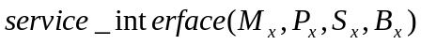
(1)
Figure 11 Service Interface

Assumptions
Describe all the assumptions used within this Mathematical Model

Formula Decomposition
M_{x} = Message (1.n)
P_{x} = PortType (1.n)
S_{x} = Service (1.1)
B_{x} = Binding (1.n)

Example

Mathematical Formula: Signature Definition

Description
This Mathematical Model defines the formula used to describe a signature within this framework. The Mathematical Model is illustrated in Figure 1.
(1)
Figure 12 Signature Definition

Assumptions
Describe all the assumptions used within this Mathematical Model

Formula Decomposition
SN_{x} = Signature Name (1.1)
I_{x} = Input (0.n)
O_{x} = Output (0.1)
DT_{x} = Data Type (0.n)

Example

Mathematical Formula: Signature Composability

Description
This Mathematical Model defines SOMETHING within this framework. The Mathematical Model is illustrated in Figure 1.

Figure 13 Signature Composability

Assumptions
Describe all the assumptions used within this Mathematical Model

Formula Decomposition
Describe the Mathematical Model

Example

Mathematical Formula: Sequential Reliability of Service Composition

Description
These Mathematical Formulas describe the sequential reliability and unreliability of service compositions using joint probability. The Mathematical Formulas are illustrated in Figure 1.

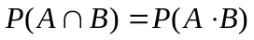
(1)
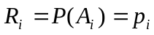
(2)
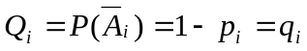
(3)
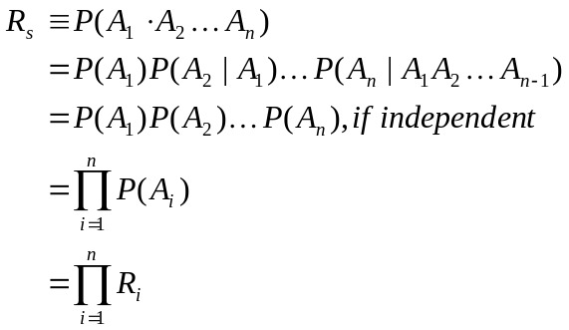
(4)
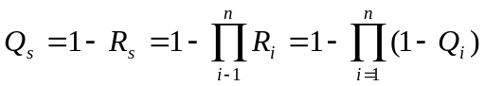
(5)

Figure 14 Serial Reliability of Service Composition

Assumptions
Describe all the assumptions used within this Mathematical Model

Formula Decomposition
In Figure 14 equation (1) defines the set theory representation for sequential reliability of service compositions. In this instance the probability of A intersection B is equal to the probability of A multiplied by the probability of B. Equation (2) describes the reliability of individual services, where R_{i} is an individual reliable service within the service space and p_{i} is the probability value indicating how reliable the service is. Equation (3) describes the unreliability of an individual service, where Q_{i} is an individual unreliable service within the service space and q_{i} is the probability value describing how unreliable the service is. Equation (4) describes the system reliability, which is the joint probability of all components using in the composition. Equation (5) describes the unreliability of the system.

Example
Assume each service has a reliability or probability of “successful” performance of 90%
P(A_{i}) = R_{i} = p = 0.90
System Reliability: R_{s} = 0.90 * 0.90 * 0.90 = 0.729
Unreliability of individual service: Q_{i} = 1 - R_{i} = 0.10
System unreliability: Q_{s} = 1 – R_{s} = 1 – p³ = 1 – (0.90)³ = 1- 0.729 = 0.271

Mathematical Formula: Parallel Reliability of Service Composition

Description
These Mathematical Formulas describe the parallel reliability and unreliability of service compositions. The Mathematical Formulas are illustrated in Figure 1.

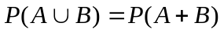
(1)
(2)
(3)
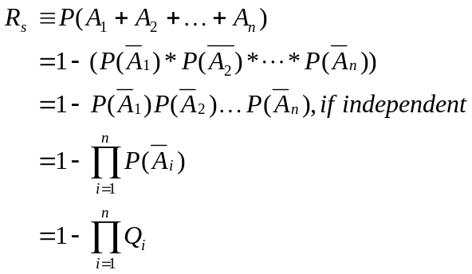
(4)
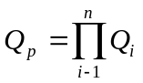
(5)

Figure 15 Parallel Reliability of Service Composition

Assumptions
The redundancy of the parallel system that allows either-or components to function, results in a system that remains functional with higher probability than the probability of either of the individual components acting alone. Therefore, redundancy increases reliability, which means that a system of n components is connected in parallel. Successful operation of each component is independent. Again, independent here implies components do not interact.

Formula Decomposition
In Figure 15 equation (1) defines the set theory representation for parallel reliability of service compositions. In this instance the probability of A union B is equal to the probability of A plus the probability of B. Equation (2) describes the reliability of individual services, where R_{i} is an individual reliable service within the service space and p_{i} is the probability value indicating how reliable the service is. Equation (3) describes the unreliability of an individual service, where Q_{i}. Is an individual unreliable service within the service space and qi is the probability value describing how unreliable the service is. Equation (4) describes the system reliability, which is the joint probability of all components. Equation (5) describes the unreliability of the system.

Example
Assume service A has a reliability or probability of “successful” performance of 90% and Service B has a reliability or probability of “successful” performance of 80%
P(A) = 0.90 and P(B) = 0.80. If this is a parallel system them
Individual Service Reliability 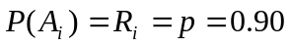
Individual Service Unreliability 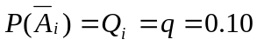
System Reliability:
System unreliability: 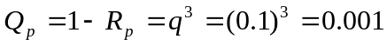

Mathematical Formula: Serial-Parallel Reliability of Service Composition

Description xxx
These Mathematical Formulas describe the sequential-parallel reliability and unreliability of service compositions. The Mathematical Formulas are illustrated in Figure 1.

(1)
(2)
(3)
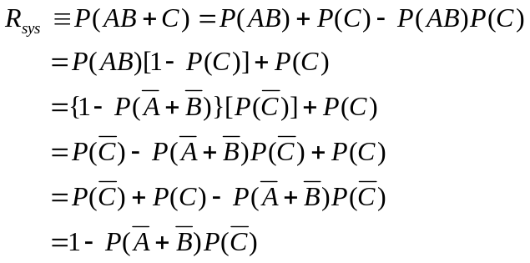
(4)
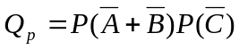
(5)

Figure 16 Serial-Parallel Reliability of Service Composition

Assumptions
The redundancy of the parallel system that allows either-or components to function, results in a system that remains functional with higher probability than the probability of either of the individual components acting alone. Therefore, redundancy increases reliability, which means that a system of n components is connected in parallel. Successful operation of each component is independent. Again, independent here implies components do not interact.

Formula Decomposition
In Figure 12 equation (1) describes the reliability of individual services, where Ri is an individual reliable service within the service space and pi is the probability value indicating how reliable the service is. Equation (2) describes the unreliability of an individual service, where Qi. Is an individual unreliable service within the service space and qi is the probability value describing how unreliable the service is. Equation (3) describes the system reliability, which is the joint probability of all components.
Example: P(A) = 0.90 and P(B) = 0.80. If this is a parallel system them
Individual Service Reliability
Individual Service Unreliability
System Reliability:
System unreliability:

Mathematical Formula: Parallel-Serial Reliability of Service Composition

Description
These Mathematical Formulas describe the sequential-parallel reliability and unreliability of service compositions. The Mathematical Formulas are illustrated in Figure 1.

(1)
(2)
(3)
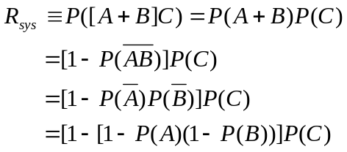
(4)
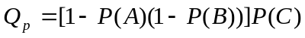
(5)

Figure 17 Parallel-Serial Reliability of Service Composition

Assumptions
The redundancy of the parallel system that allows either-or components to function, results in a system that remains functional with higher probability than the probability of either of the individual components acting alone. Therefore, redundancy increases reliability, which means that a system of n components is connected in parallel. Successful operation of each component is independent. Again, independent here implies components do not interact.

Formula Decomposition
In Figure 12 equation (1) describes the reliability of individual services, where Ri is an individual reliable service within the service space and pi is the probability value indicating how reliable the service is. Equation (2) describes the unreliability of an individual service, where Qi. Is an individual unreliable service within the service space and qi is the probability value describing how unreliable the service is. Equation (3) describes the system reliability, which is the joint probability of all components.
Example: P(A) = 0.90 and P(B) = 0.80. If this is a parallel system them
Individual Service Reliability
Individual Service Unreliability
System Reliability:
System unreliability:

References

